<https://www.youtube.com/watch?v=ZDa-Z5JzLYM>

This code snippet creates the class “Employee”. This class shares all it’s attributes among all instances of “Employee”. The “init” method takes attributes of the first and last names, the pay, and from the first and last names constructs the employee email. The parameter “self” is telling the “Employee” class that it should be creating an instance of the class with all the attributes. We create emp_1 and emp_2 and pass the parameters for the employees into the class “Employee”. In “fullname”, we must pass “self” so that the method knows it is being called on whatever instance of self we’re using “fullname” on. The last two lines of code accomplish the same thing, they’re just showing examples of how to print the full name of the employee we’ve specified

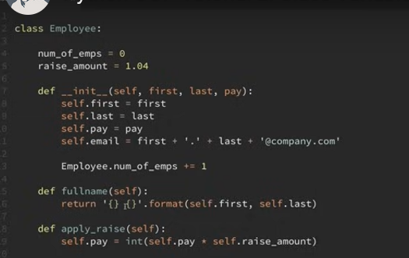

<https://youtu.be/BJ-VvGyQxho>

In the first screenshot of this section there is a line of code under the class “Employee” which sets the “raise_amount” to 1.04 or 4%. If the “raise_amount” is not set for an individual instance like emp_2 or unlike emp_1, it will fall back to the class defined “raise_amount”. The way this is coded is that in the method “apply_raise” the raise is determined from the instance’s “raise_amount” this is done with – self.raise_amount we could alternatively set this to be Employee.raise_amount and the method would fall back to the class defined “raise_amount” every time instead of the instance’s “raise_amount”.

<https://youtu.be/rq8cL2XMM5M>

In order to make a class method we use the decorator @classmethod as seen in the code snippet above. To use a class method typically the first argument will be “cls” instead of self like our other methods from this example. We can then use the class method in the general code to set the raise amount for the whole class to whatever we’d like, in this case 5% instead of 4%. We can also set the class amount by using the class method on an instance instead of a class. If we say “Employee.set_raise_amt()” and “emp_1.set_raise_amt()” it will accomplish the same thing. In this case emp_1 is an instance of the class Employee so when we defined the set_raise_amt() method and told it to accept a class as the first argument, it is taking the class of the instance “emp_1” rather than that specific instance which is “self” in the other methods of this example.

They are using this class method “from_string” as an alternative constructor for a new employee. They take the string of employee data, feed it to the class method, parse it, and run the class method and it creates a new employee for us.

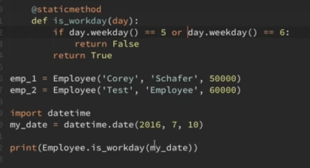

Static methods do not pass the instance or class in the arguments i.e. “self” or “cls” either explicitly or implicitly but they typically are logically related to the class itself but don’t need to reference the class. The static method is created with just the arguments we want to work with and the decorator @staticmethod. If your method doesn’t need to use the “self” or “cls” argument it can likely be a static method.



<https://youtu.be/RSl87lqOXDE>

In order to create subclasses, you create your new class with the name of the parent class(es) in parenthesis. This will create your subclasses with all of the functionality and structure from the inherited class info while being tailored to the specific needs of the subclass. To add an additional argument to a subclass, you need to structure your code as follows:

Another example is the manager subclass.

When creating the subclass “Manager” there may be temptation to give the argument “employees” as an empty list, but you should not give the option of mutable data types for the entry argument. Creating a new manager and editing the manager’s list of employees in the main code should look something like this:

With the code isinstance() or issubclass() we can check the structure of inheritance on different types of employees. This example checked if an employee name belonged to a subclass.

There are some magic or special methods that developers often use:

<https://youtu.be/3ohzBxoFHAY>

repr and str are very common. The repr method is typically used for developers to return the exact fields used to create a certain instance of an object, while str is often used to print for the end user of the program. The commented lines and regular lines in the following screengrab print the same thing.

Now we’ll look at another magic method which is the addition of class items. You can specify how the addition is carried out using code similar to the following screengrab:

You may select certain attributes of your objects to interact with using the add function and tailor it to your specific use case.

If you need to do something else you can also write code for subtraction, multiplication, division, length, and other special methods. They’re all organized similar to __add__ above which is set up as a “dunder” (double underscore). You can use this functionality to tailor your program to perform the specific actions you’re trying to achieve.

There is also the option to use a decorator which will enable us to do different things with our programs. Using the @property decorator allows us to treat the method specified underneath it as if it were an attribute of another class that will update without torpedoing the rest of your code or implemented program.

<https://youtu.be/jCzT9XFZ5bw>

We are able to use decorators for setters and deleters as well.

